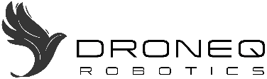
PRESS RELEASE
2026 April 02

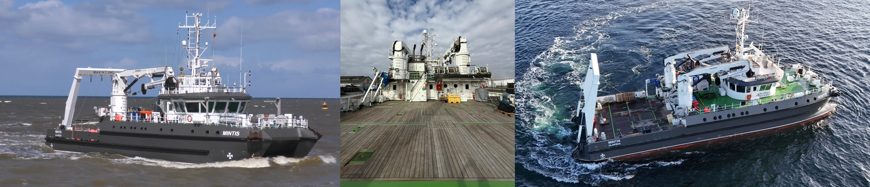

PARTNERSHIP MARK OFFSHORE AND DRONEQ ROBOTICS: R/V MINTIS
Unmanned robotics services provider DroneQ Robotics and offshore support and vessel management Mark Offshore have struck a deal on the latter’s new fleet addition ‘R/V Mintis’. Mark Offshore manages and operates the DP1 ROV Support & Survey vessel. DroneQ Robotics now has the exclusive rights to deploy the vessel for its own projects, Intertek projects, and third-party projects.
DroneQ Robotics has made a strategic decision to deploy the Mintis as ROV Support & Survey Vessel, offering the platform as a combination of vessel, ROV equipment and services, and drone equipment and services. Mark Offshore and DroneQ Robotics have already collaborated for many years, and have built a strong relationship based on mutual trust.
Mark Offshore, specialized in maritime consultancy, vessel brokerage & management, and subsea support services, has recently taken a new step by handling the management and operations of the multi-functional research and survey vessel R/V Mintis for its owners, Klaipėda University from Lithuania.
New ROV systems on board:
- The powerful X-SV, OCROV Class I ROV system (2026) rated for 350m working depth with 4K inspection camera, 4K electronic pan-tilt 220° hemispheric panoramic camera, 4.5 knots speed, DVL, built-in adjustable Obstacle Detection & Avoidance system, USBL, imaging sonar, Side Scan Sonar, UT and CP probes, underwater cavitation cleaning system, water sampling system and a 2-function gripper system.
- The advanced Argus Rover, OCROV Class II ROV system (2025) with WCROV capabilities rated for 1000m working depth, advanced station keeping system with Sonardyne SPRINT-NAV INS + DVL, USBL, subsea 3D imaging capabilities powered by Voyis Discovery Stereo with VSLAM technology, imaging sonar, UT, CP and FMD NDT probes, onboard High Pressure and Flexiclean underwater cleaning systems, and a HydroLek 5600 manipulator skid (50 kgs lifting capacity at full reach). The 3D system comes with a luxurious 20ft Control Room/Workshop DNV certified Offshore container and a 10ft Winch DNV certified Offshore Container.
In addition, R/V Mintis will be equipped with industrial Maritime Inspection Drones, designed to take-off and land on vessels at open sea, for Offshore Wind turbine and Offshore Oil & Gas installation aerial inspections.
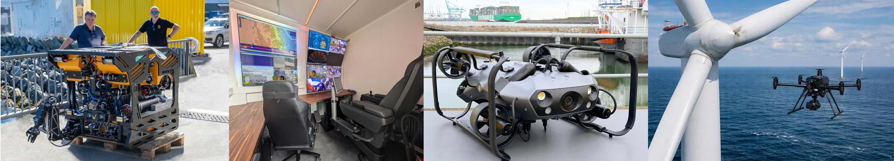
John Troch, Co-founder of DroneQ Robotics and Director Marine Services: “The partnership with Mark Offshore and this vessel is a big leap forward in the growth of DroneQ Robotics in general, and our Advanced Unmanned Robotics Services, AURS, proposition for the offshore market in particular! The market is beginning to realize that Big, Bigger, Biggest is not always the best solution.”

R/V Mintis
R/V Mintis is a DP1 vessel with a long track record in combining operational and cost efficiency in shallow and deep waters. It has the capability to conduct a wide variety of AURS services for the Ports, Offshore Oil & Gas, Offshore Wind and Salvage markets. DroneQ Robotics will deploy the vessel for projects such as subsea inspection and construction work with ROV’s, and magnetic crawler robots, offshore drone inspection, salvage support and survey tasks. It is often deployed for bathymetric surveys, UXO campaigns, pipeline and cable sub bottom surveys and ecological oceanographic research.
John Troch adds: “We truly believe that our strong partnership with Mark Offshore, which draws on both our fields of expertise, will add value to our existing and new customers, and our partner Intertek. With the R/V Mintis we now operate a cutting-edge, fully outfitted vessel, both as to offshore inspection equipment and expert personnel.”
Mark van der Star, Managing Director Mark Offshore, adds: “Due to our long-standing relationship with John, and our shared drive to deliver results, our cooperation already translated into a concrete project in the very first week of our commercial management of R/V Mintis. This underlines our commitment: when shipowners partner with Mark Offshore, we don’t just manage vessels, we actively turn them into revenue-generating assets from day one. To see that becoming reality with R/V Mintis is something we’re really proud of.”

======================================================================================================
For more information or questions, please contact:
John Troch
DroneQ Robotics,
Director Marine Robotics Services
john@droneq.nl
www.droneq.nl

----------------------------------------------------------------------------------------------------------------------------------------------------------------------

About DroneQ Robotics
DroneQ Robotics is a Dutch based global next-generation Advanced Unmanned Robotics Services provider, with over 40 years’ experience in the industrial sector and maritime industry, including maritime disaster response & salvage and Offshore Energy.
Advanced Unmanned Robotics Services, AURS, is a global DroneQ Robotics service, which deploys dedicated and trained professionals and cutting-edge unmanned robotics equipment. AURS deliver worldwide ultrahigh-resolution inspections and surveys, 3D imaging and Non-Destructive Testing: underwater, on the water and from the air. Helping clients in Industry and Ports, Offshore Oil & Gas and Offshore Wind to assess the integrity condition of their valuable assets, supporting advanced analytics for Lifespan Extension strategies, Fitness for Service analysis and many more.

About Mark Offshore
Mark Offshore is a rapidly evolving offshore services company specializing in inspection support, subsea operations, ecological research support, and project facilitation. Rooted in years of practical marine experience and an extensive global network, we are transforming into an asset-based offshore inspection contractor equipped with our own vessels and subsea capabilities. We deliver reliable, efficient, and safety-driven solutions for clients operating in offshore wind, subsea infrastructure, environmental monitoring, and marine energy environments.

